DISTRIBUTED DATABASES
Agenda
- Distributed Databases
- Characteristics and Benefits
- Real-World Use Cases
- CAP Theorem
- Trade-Offs in CAP Theorem
- Types of Distributed Databases
- Replication vs Sharding
- Design Considerations
- Distributed Databases Architecture
- Consistency
- Challenges
Distributed Databases:
A Distributed Database (DDB) is a database in which data is stored across multiple physical locations, either on different servers within the same data center or spread across different geographical locations. These databases ensure data availability, fault tolerance, and scalability, making them essential for modern Data Engineering tasks.
In Data Engineering, distributed databases play a crucial role in handling large-scale data processing, real-time analytics, and ensuring high availability for applications. They help in managing big data efficiently across cloud and on-premises infrastructures.
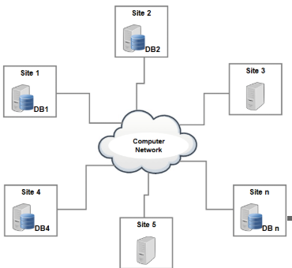
Characteristics of Distributed Databases:
1. Data Distribution
- The data is partitioned (sharded) and stored across multiple servers.
- Can follow horizontal partitioning (splitting rows) or vertical partitioning (splitting columns).
2. Replication & Redundancy
- Copies of data are stored in multiple locations to ensure fault tolerance and high availability.
- Helps in load balancing and reducing latency for distributed queries.
3. Scalability
- Can handle growing amounts of data by adding more nodes (horizontal scaling) instead of upgrading a single machine (vertical scaling).
- Essential for big data and real-time processing in data engineering.
4. Concurrency Control
- Ensures data consistency when multiple users or systems access the database simultaneously.
- Uses techniques like Multi-Version Concurrency Control (MVCC) or locking mechanisms.
5. Fault Tolerance
- If one node fails, the system continues to function using other nodes.
- Uses techniques like replication, consensus protocols (Raft, Paxos), and data recovery mechanisms.
6. Data Transparency
- The user interacts with the database as if it's a single unit, without knowing the underlying distributed nature.
- Types of transparency:
  - Location Transparency: Users don’t need to know where data is stored.
  - Replication Transparency: Users don’t need to manage multiple copies.
  - Failure Transparency: System recovers automatically in case of failures.
7. Query Processing & Optimization
- Queries are distributed across multiple nodes, requiring distributed query execution plans.
- Tools like Apache PySpark, and Google BigQuery optimize query performance in distributed environments.
Benefits of Distributed Databases in Data Engineering:
1. High Availability & Fault Tolerance
- Ensures continuous access to data even if some nodes fail.
- Critical for real-time data pipelines and cloud-based analytics.
2. Scalability for Big Data
- Distributed databases allow seamless handling of petabytes of data.
- NoSQL databases (Cassandra, MongoDB) and Cloud databases (BigQuery, Snowflake, Amazon DynamoDB) are designed for large-scale data engineering applications.
3. Improved Performance & Low Latency
- Data locality: Queries are processed closer to where the data resides, reducing delays.
- Load balancing across multiple servers improves query response times.
4. Cost Efficiency
- Horizontal scaling (adding more machines) is cheaper than upgrading a single powerful server.
- Cloud-based distributed databases offer pay-as-you-go pricing, reducing infrastructure costs.
5. Easy Integration with Big Data Technologies
- Works seamlessly with Apache Spark, Kafka, Hadoop, and cloud-based analytics tools.
- Enables real-time data processing, ETL pipelines, and machine learning model training.
6. Supports Global Applications
- Ideal for applications requiring multi-region data replication and access.
- Helps in compliance with data regulations like GDPR by storing data in specific regions.
Real-World Use Cases of Distributed Databases:
1. Global-Scale Applications (Social Media & E-Commerce)
- Companies like Facebook, Twitter, Amazon, and Alibaba use distributed databases (e.g., Cassandra, DynamoDB, Spanner) to store user data across multiple data centers worldwide.
- Ensures low-latency access for users across different regions.
- Supports real-time updates and high availability.
2. Financial Services & Banking
- Banks and fintech companies use distributed databases (CockroachDB, Spanner, FoundationDB) for global transactions.
- Ensures high consistency in transactions (ACID compliance).
- Enables fraud detection in real time by analyzing distributed data.
3. Streaming & Real-Time Analytics (Big Data)
- Companies like Netflix, YouTube, and Spotify use distributed databases (e.g., Apache Cassandra, Google Bigtable, ClickHouse) for real-time analytics on user activity.
- Helps in content recommendations, tracking user engagement, and optimizing streaming quality.
4. IoT & Edge Computing
- Industrial IoT platforms (e.g., Tesla, GE, Siemens) use distributed databases to collect and process sensor data from millions of devices.
- Databases like TimeScaleDB, InfluxDB, or Apache Ignite handle time-series data efficiently.
- Supports predictive maintenance by analyzing sensor readings from distributed locations.
5. Healthcare & Genomics
- Distributed databases power platforms like 23andMe, Human Genome Project, and electronic health records (EHRs).
- Google Cloud Healthcare API and distributed NoSQL databases enable fast query execution on medical records.
- Ensures data privacy & compliance (HIPAA, GDPR).
6. Ride-Sharing & Logistics
- Uber, Lyft, and FedEx use distributed databases (Cassandra, DynamoDB, PostgreSQL with Citus) for real-time tracking and route optimization.
- Enables geospatial data processing at a global scale.
- Provides low-latency access to traffic, driver, and customer data.
7. Retail & Inventory Management
- Walmart, Amazon, and Flipkart use distributed databases for managing real-time inventory across warehouses.
- Ensures accurate stock tracking to avoid overselling.
- Uses NewSQL solutions like Spanner or NoSQL like DynamoDB for consistency and scalability.
8. Cybersecurity & Threat Detection
- Security companies like Palo Alto Networks and CrowdStrike use distributed databases to store logs from various endpoints.
- Apache Kafka + distributed databases help in real-time threat detection and response.
9. Blockchain & Cryptocurrency
- Cryptocurrencies like Bitcoin, Ethereum, and Solana use distributed ledger databases.
- Provides decentralized and tamper-proof data storage.
- Ensures fault tolerance and removes central points of failure.
10. Scientific Research & Climate Modeling
- NASA, CERN, and climate research institutes use distributed databases (e.g., HBase, Cassandra, SciDB) to store and analyze large-scale scientific datasets.
- Enables simulations for weather forecasting and astrophysics.
CAP Theorem:
The CAP Theorem, proposed by Eric Brewer in 2000 and later proven by Gilbert and Lynch in 2002, states that in a distributed data store, it is impossible to achieve all three of the following simultaneously:
- Consistency (C)
- Availability (A)
- Partition Tolerance (P)
Any distributed system can only guarantee two out of the three properties at the same time.
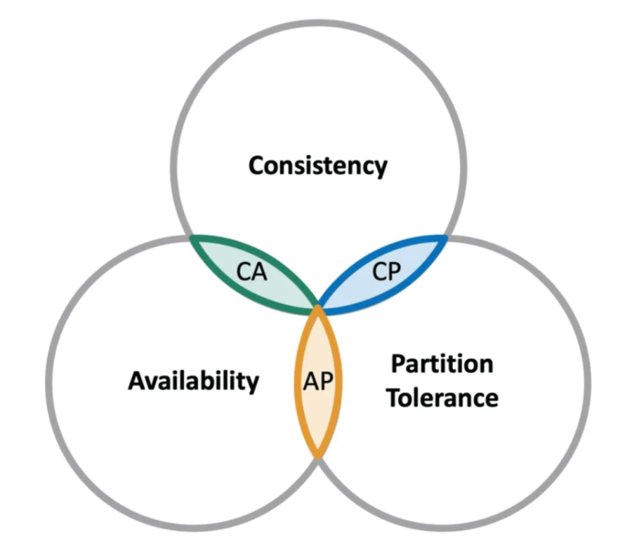
Components of CAP Theorem:
1. Consistency:
- Consistency in CAP Theorem ensures that all nodes in a distributed system always return the most recent write for a data item.
- It guarantees that if a piece of data is updated, all subsequent read operations will reflect the latest update across all nodes.
Working:
- When a transaction updates data, that update must be propagated to all replicas before any other transaction can read the data.
- Clients accessing different nodes should always receive the same data.
Types of Consistency Models:
- Strong Consistency (Sequential Consistency)
  - All nodes return the latest committed value.
  - Every read reflects the most recent writing.
  - Example: Distributed relational databases (e.g., Google Spanner, HBase).
- Eventual Consistency
  - Nodes may return stale data, but eventually, all copies of the data will become consistent.
  - Used in highly available systems where updates are asynchronously propagated.
  - Example: DNS systems, NoSQL databases like DynamoDB, Cassandra.
- Causal Consistency
  - Ensures that operations that are causally related are seen in the same order on all nodes.
  - Example: Social media platforms (e.g., If you comment on a post, it appears under the post, not before it).
Example of Consistency in CAP:
Imagine a banking system where:
- A user has ₹500 in their account.
- The user spends ₹200.
- The balance should immediately update to ₹300 across all nodes.
- If a node still shows ₹500, there is an inconsistency.
Challenges in Consistency:
- Network Latency: Propagating updates across all nodes takes time.
- Conflict Resolution: When two nodes update the same data simultaneously.
- Trade-off with Availability: Enforcing consistency may require rejecting some requests during updates.
2. Availability:
- Availability in CAP Theorem ensures that every request (read/write) receives a response regardless of whether some nodes in the system have failed.
- A system is considered available if every non-failing node can respond within a reasonable time, even during network failures.
Characteristics:
1. No Request is Rejected
- Every client request must get a response (success or failure).
- Even if some nodes are down, the system should provide data.
2. Fast Response Time
- The system must respond quickly, regardless of network failures or data consistency issues.
3. No Guarantees on the Most Recent Data
- Unlike consistency, availability does not ensure the latest update is reflected in all responses.
- The system may return stale or outdated data but will not reject the request.
Working:
- When a request is made, the system returns a response, even if some nodes in the distributed system are not synchronized.
- To ensure availability, distributed systems replicate data across multiple nodes, so that even if some nodes fail, others can still process requests.
Examples:
Example 1: Social Media Subscriptions
- A content creator (User A) has 1000 subscribers.
- A new user (User B) subscribes from a different region.
- Due to network latency, some database nodes haven’t updated the new subscriber count.
- The system still allows User B to subscribe without rejecting the request.
- Trade-off: If User C checks the subscriber count at the same time, they may see 1000 instead of 1001 temporarily.
Example 2: E-Commerce Product Stock
- A user is shopping online for a mobile phone.
- Due to high demand, the stock is updating continuously.
- If the database prioritizes availability, users can still add the item to their cart, even if another customer has already purchased the last piece.
- Trade-off: The system may later notify the user that the item is out of stock.
Challenges:
- A node may return outdated data if updates have not propagated.
- To ensure fast response, the system may return inconsistent data.
- Two Users may update the same data before the system synchronizes them.
3. Partition Tolerance:
- Partition Tolerance (P) means that the system continues to operate even when network failures occur that partition the system into multiple disconnected segments.
- In distributed systems, network failures are inevitable, so partition tolerance is a fundamental requirement.
Characteristics:
- Continued Operation Despite Network Failures
  - The system does not crash or stop responding even if network communication between nodes is lost.
- Data Replication Across Partitions
  - A distributed system must store redundant copies of data across multiple nodes to ensure availability during partitions.
- Temporary Inconsistencies May Occur
  - Some nodes may not have the latest updates when a network partition happens.
Working:
- In a distributed system, nodes are connected via a network.
- If the network fails or becomes slow, nodes cannot communicate with each other.
- A partition-tolerant system continues to function by:
  - Serving requests from available nodes
  - Syncing data later when the network is restored
Examples:
Example 1: Social Media Network
- A social media app has millions of users worldwide.
- Due to a network issue, some regional servers lose connection with others.
- Users in those regions can still post and interact with the app.
- Once the partition is resolved, the new posts are synced across all servers.
Example 2: E-Commerce Stock Management
- An online store has multiple database servers across locations.
- A network partition causes one store’s inventory data to be out of sync.
- Customers can still place orders using local data.
- Once the network is restored, the inventory updates are synchronized.
How Partition Tolerance is Achieved:
1. Data Replication
- Data is stored on multiple nodes, so even if one node becomes inaccessible, another node can serve the request.
2. Eventual Consistency
- Instead of forcing immediate consistency, the system allows temporary inconsistencies and synchronizes data later.
3. Distributed Consensus Protocols
- Algorithms like Raft, Paxos, and Gossip Protocol help nodes agree on data changes even in case of partitions.
Trade-Offs in the CAP Theorem:
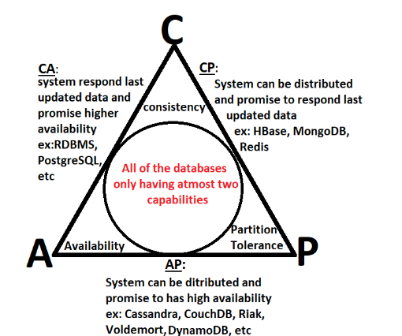
1. Trade-off: CP (Consistency + Partition Tolerance, but not Availability):
- Ensures strong data consistency, even at the cost of availability during network failures.
- When a partition occurs, the system may reject some requests or become temporarily unavailable to ensure that all nodes remain in sync.
- This is useful in cases where accurate, up-to-date data is more important than high availability.
Pros:
- Strong data consistency across nodes.
- Ensures accurate and synchronized data.
Cons:
- Availability is sacrificed; the system may become unresponsive during network failures.
- Slower response times due to synchronization overhead.
Examples:
- Relational Databases (SQL-based) like PostgreSQL, MySQL (with strict replication settings).
- Distributed Systems such as HBase and Google Bigtable, which prioritize consistency over availability.
2. Trade-off: AP (Availability + Partition Tolerance, but not Consistency):
- Guarantees that the system remains available, even during network failures.
- However, it sacrifices strong consistency, meaning different nodes might return different versions of the same data.
- This is suitable for systems where high availability is more important than perfectly synchronized data.
Pros:
- Ensures high availability, even during network failures.
- Faster responses, as nodes don’t wait for full synchronization.
Cons:
- Eventual consistency, meaning data may be outdated for some time.
- Potential data inconsistencies if updates occur during a partition.
Examples:
- NoSQL Databases like Cassandra, DynamoDB, CouchDB, and Riak.
- Content Delivery Networks (CDNs), which prioritize availability for users across different locations.
3. Trade-off: CA (Consistency + Availability, but not Partition Tolerance):
- Ensures strong consistency and availability as long as there are no network partitions.
- However, in a real-world distributed system, partitions are unavoidable, meaning this scenario is only practical for single-node databases or tightly connected clusters.
Pros:
- Strong data consistency across nodes.
- High availability as long as the network remains intact.
Cons:
- Fails completely when a partition occurs.
- Not practical for large-scale distributed systems.
Examples:
- Traditional RDBMS running on a single server (e.g., Oracle, MySQL, PostgreSQL without replication).
- Enterprise Database Systems with tightly controlled network infrastructure.
Types of Distributed Databases:
1. Based on Data Distribution:
A. Replicated Databases
- In a replicated database, multiple copies of the same data are stored across different nodes in the distributed system.
- Ensures high availability and fault tolerance.
- Useful for read-heavy workloads where multiple users need fast access to the same data.
- Types of Replication:
  - Full Replication: Entire database is copied to each node.
  - Partial Replication: Only selected portions of data are copied to certain nodes.
- Examples:
  - Google Spanner
  - Amazon Aurora
  - Apache Cassandra (uses multi-node replication)
B. Sharded (Partitioned) Databases
- In sharding, the database is split into smaller parts (shards) and distributed across multiple servers.
- Each shard contains a subset of data, reducing storage overhead on any single node.
- Used in write-heavy workloads where scalability is a priority.
- Types of Sharding:
  - Horizontal Sharding: Distributes rows across multiple databases.
  - Vertical Sharding: Distributes columns across multiple databases.
- Examples:
  - MongoDB (supports horizontal sharding)
  - Apache HBase
  - Amazon DynamoDB
2. Based on Architecture:
A. Centralized Distributed Database
- A single central database manages distributed nodes.
- All requests and transactions go through a central system.
- Pros: Easier to maintain consistency and security.
- Cons: Can become a bottleneck and introduce latency.
- Example: A distributed SQL database with a primary server coordinating transactions.
B. Decentralized (Peer-to-Peer) Distributed Database
- No single central database; all nodes are equal and communicate directly.
- More fault-tolerant and scalable than centralized systems.
- Pros: Avoids single points of failure and scales dynamically.
- Cons: Complex to maintain consistency and synchronization.
- Example: Apache Cassandra (decentralized peer-to-peer architecture).
3. Based on Database Model:
A. Distributed Relational Databases (SQL-Based)
- Follow ACID (Atomicity, Consistency, Isolation, Durability) properties.
- Use SQL for querying.
- Ensure strong consistency but may face scalability limitations.
- Examples:
  - Google Spanner
  - CockroachDB
  - Amazon RDS (Multi-AZ deployments)
B. Distributed NoSQL Databases
- Follow BASE (Basically Available, Soft state, Eventual consistency) model.
- Optimized for high availability and horizontal scalability.
- Types:
  - Key-Value Stores (Amazon DynamoDB, Redis)
  - Document Stores (MongoDB, CouchDB)
  - Column-Family Stores (Apache Cassandra, HBase)
  - Graph Databases (Neo4j, Amazon Neptune)
Replication vs Sharding:
FACTOR | REPLICATION | SHARDING
Definition | Copying and maintaining identical data across multiple database servers. | Dividing a database into smaller, independent partitions (shards) distributed across multiple servers.
Purpose | Ensures high availability, redundancy, and fault tolerance. | Enhances scalability, performance, and write efficiency.
Data Distribution | Entire copies of the database are stored on multiple servers. | The database is split into independent shards, each containing a portion of the data.
Read vs. Write Performance | Improves read performance as multiple replicas can serve read queries. | Improves write performance by distributing write load across multiple shards.
Storage Overhead | High, as multiple copies of the same data exist. | Low, as each shard contains only a subset of the data.
Fault Tolerance | High – If one replica fails, other copies are available. | Moderate – If a shard fails, data in that shard becomes unavailable.
Data Consistency | Can be challenging; updates must be synchronized across replicas. | Each shard maintains independent consistency, but cross-shard consistency is harder to manage.
Complexity | Easier to implement but requires syncing mechanisms. | More complex due to partitioning logic, routing queries, and rebalancing shards.
Scaling Approach | Vertical scaling – More copies help handle increased read traffic. | Horizontal scaling – Data is partitioned across multiple servers for better performance.
Load Balancing | Works well for read-heavy applications, as read queries are distributed across replicas. | Works well for write-heavy applications, as write queries are split across different shards.
Synchronization Overhead | High – Changes to the master must be replicated across all copies. | Low – Each shard is independent, reducing the need for synchronization.
Cross-Node Queries | Not an issue; every replica holds the complete dataset. | Complex – Queries spanning multiple shards require query routing and aggregation.
Failure Impact | A replica failure has minimal impact as other copies exist. | A shard failure can cause partial data loss if not handled properly.
Use Cases | Read-heavy applications, backups, disaster recovery, caching layers. | Large-scale applications, high-throughput systems, distributed databases.
Example Technologies | MySQL Replication, PostgreSQL Streaming Replication, MongoDB Replication. | Amazon DynamoDB, Apache Cassandra, Google Bigtable.
Real-World Example | Facebook replicates posts across multiple data centers for availability. | Instagram shards user posts to different database clusters for scalability.
Centralized vs. Decentralized Architecture:
FACTOR | CENTRALIZED ARCHITECTURE | DECENTRALIZED ARCHITECTURE
Definition | A single, central database/server manages all data and processing. | Multiple independent servers/nodes store and manage data across different locations.
Data Storage | All data is stored in one central location (single point of control). | Data is distributed across multiple nodes or regions.
Processing Control | The central server processes all read/write operations. | Processing is distributed among multiple servers.
Fault Tolerance | Low – If the central server fails, the entire system goes down. | High – If one node fails, others can continue functioning.
Scalability | Limited – Hard to scale beyond a certain capacity. | Highly scalable – New nodes can be added dynamically.
Latency | Can be high for users far from the central server. | Lower latency as data is closer to users.
Network Dependency | High – Clients must always be connected to the central system. | Lower – Some nodes can operate independently.
Data Consistency | High – A single source of truth ensures strong consistency. | Can be difficult to maintain strong consistency across multiple nodes.
Performance | Slower for large-scale applications as all requests go to a single server. | Faster due to distributed processing and load balancing.
Security | Easier to enforce security policies from a central location. | Harder to enforce security across multiple nodes.
Complexity | Simpler to maintain and manage. | More complex due to synchronization and coordination challenges.
Use Cases | Banking systems, traditional relational databases, ERP systems. | Blockchain, peer-to-peer networks, distributed cloud storage.
Example Technologies | MySQL, Oracle, IBM DB2, SQL Server. | Bitcoin, Ethereum, Google Cloud Spanner, Apache Cassandra.
Real-World Example | Traditional banking systems store transaction records in one central database. | Google Cloud distributes user data across multiple data centers for fault tolerance.
Use Cases:
1. Replication vs. Sharding
- Use Replication when focusing on high availability & redundancy.
- Use Sharding for scalability & performance optimization in large-scale applications.
2. Centralized vs. Decentralized
- Centralized architecture is simpler & ensures consistency, but has scalability and failure risks.
- Decentralized architecture is more scalable & fault-tolerant, but requires better coordination & security measures.
Design Considerations of Distributed Databases:
When designing a Distributed Database System (DDBS), several key considerations must be taken into account to ensure efficiency, consistency, and reliability. Below are some critical design considerations:
1. Data Distribution Strategies:
- Fragmentation: Dividing the database into smaller parts (fragments) and storing them at different sites.
  - Horizontal Fragmentation: Dividing tables by rows.
  - Vertical Fragmentation: Dividing tables by columns.
  - Hybrid Fragmentation: A combination of horizontal and vertical fragmentation.
- Replication: Copying and storing data at multiple locations to improve availability and reliability.
- Allocation: Deciding which fragments should be stored at which sites for optimal performance.
2. Data Consistency and Concurrency Control
- Replication Consistency: Ensuring all copies of the data are synchronized.
- Concurrency Control Mechanisms:
  - Two-Phase Locking (2PL)
  - Timestamp Ordering
  - Optimistic Concurrency Control
- Eventual Consistency vs. Strong Consistency: Choosing the right consistency model based on the application's needs.
3. Scalability and Performance
- Load Balancing: Distributing queries and transactions efficiently to avoid overload on any single node.
- Parallel Query Processing: Executing queries across multiple nodes to enhance performance.
- Indexing and Caching: Using distributed indexing and caching techniques to speed up data retrieval.
4. Fault Tolerance and Reliability
- Redundancy: Using multiple copies of data to recover from failures.
- Failure Recovery Strategies:
  - Checkpoints and Logs
  - Replication and Data Backups
  - Automated Failover Mechanisms
- Partition Tolerance: Handling network failures while maintaining service availability.
5. Network Latency and Communication Overhead
- Minimizing Data Transfer Costs: Reducing the volume of data transferred between sites.
- Efficient Query Routing: Using query optimization techniques to minimize delays.
- Compression Techniques: Applying data compression to reduce bandwidth usage.
6. Security and Access Control
- Data Encryption: Encrypting data during transmission and at rest.
- Authentication & Authorization: Implementing role-based access control (RBAC) or attribute-based access control (ABAC).
- Intrusion Detection Systems (IDS): Monitoring unauthorized access attempts.
7. Database Transparency
- Location Transparency: Users should not need to know where data is physically stored.
- Replication Transparency: The system should handle data replication without user intervention.
- Failure Transparency: The system should recover from failures without affecting the user experience.
8. Query Processing and Optimization
- Distributed Query Processing: Optimizing queries to fetch data from multiple sites efficiently.
- Cost-Based Query Optimization: Evaluating query execution plans to minimize cost.
- Join Optimization: Reducing network overhead when performing distributed joins.
9. Compliance and Legal Considerations
- Data Sovereignty: Adhering to country-specific data storage regulations.
- GDPR & Other Compliance Requirements: Ensuring the system follows data protection laws.
- Audit Logging: Maintaining logs for accountability and regulatory compliance.
Distributed Databases Architecture:
A Distributed Database Architecture defines how databases are organized across multiple locations and how they interact to store, manage, and process data. It ensures efficient data distribution, fault tolerance, and optimized query execution.
Types of Distributed Database Architectures:
1. Client−Server Architecture:
In the Client-Server Architecture, a centralized server manages the database, and multiple clients interact with it to send queries and retrieve results.
Features:
- Clients request data, and the server processes queries.
- The server manages data storage, transaction control, and access management.
- Clients do not store data locally but rely on the server for information retrieval.
Advantages:
- Simplified implementation with centralized control.
- Efficient query processing as the server handles all requests.
- Security and access control are easier to enforce.
Disadvantages:
- Single point of failure—if the server fails, the entire system may be impacted.
- Scalability issues—as the number of clients increases, the server may become a bottleneck.
2. Peer−to−Peer (P2P) Architecture:
In Peer-to-Peer Architecture, every node acts as both a client and a server, meaning there is no central authority.
Features:
- Each node has equal authority and manages its data independently.
- Data and queries are distributed across multiple nodes.
- Nodes communicate directly with each other to process and store data.
Advantages:
- High fault tolerance—failure of one node does not disrupt the entire system.
- Decentralized control—no single point of failure.
- Efficient load balancing—work is distributed evenly across nodes.
Disadvantages:
- Complex synchronization—ensuring data consistency across all nodes is challenging.
- Increased overhead—since every node manages data and transactions.
3. Federated Architecture:
In Federated Architecture, multiple independent databases are combined into a single virtual database system.
Features:
- Each database remains independent while being part of the federated system.
- A virtual database manager distributes queries across different databases.
- Useful when integrating heterogeneous databases from different systems.
Advantages:
- Flexibility—allows different database systems to function together.
- No need for data migration—existing databases can be connected without modification.
- Good for legacy systems—useful when integrating old and new databases.
Disadvantages:
- Performance overhead—query execution across multiple independent databases can be slow.
- Data consistency challenges—ensuring synchronization between independent databases.
4. Shared−Nothing Architecture:
In the Shared-Nothing Architecture, each node operates independently and does not share memory or disk storage with other nodes.
Features:
- Each node has exclusive access to a specific subset of the data.
- Nodes communicate over a network but do not share computing resources.
- Well-suited for big data applications and large-scale distributed systems.
Advantages:
- Scalability—easy to add more nodes as the system grows.
- High fault tolerance—failure of one node does not affect the others.
- Efficient parallel processing—nodes handle queries independently.
Disadvantages:
- Data partitioning complexity—requires efficient data distribution strategies.
- Higher latency—some queries may require communication between multiple nodes.
Choosing the Right Architecture:
The selection of a distributed database architecture depends on various factors such as fault tolerance, scalability, performance, and consistency. Below is a comparison of these architectures:
Architecture | Scalability | Fault Tolerance | Performance | Complexity
Client-Server | Low | Low | Moderate | Low
Peer-to-Peer | High | High | Moderate | High
Federated | Moderate | Moderate | Low | High
Shared-  Nothing | High | High | High | High
Consistency in Distributed Databases:
Consistency in distributed databases refers to the guarantee that all nodes in the system have the same data at the same time. When multiple replicas of data exist across different nodes, ensuring that all copies remain synchronized is critical.
Distributed databases handle consistency using different models based on their design goals (availability, performance, fault tolerance).
Types of Consistency Models in Distributed Databases:
Consistency models define the rules for how and when updates to data are reflected across all nodes in a distributed system. The two broad categories are:
1. Strong Consistency
2. Weak Consistency (Eventual Consistency, Causal Consistency, etc.)
1. Strong Consistency:
- Ensures that all nodes see the same data at the same time.
- After a write operation, all subsequent reads must return the latest written value.
- This requires synchronization mechanisms like distributed locking, consensus algorithms (e.g., Paxos, Raft).
Example: In Google Spanner, if a write operation occurs on one replica, all reads from any other replica must reflect that change immediately.
Advantages:
- Guarantees data correctness.
- No stale reads.
Disadvantages:
- Slower performance due to synchronization overhead.
- Less available in case of network failures (CAP theorem trade-off).
Used in: Banking, financial transactions, distributed ledgers.
2. Weak Consistency:
- Updates do not have to be immediately reflected across all nodes.
- Reads might return old (stale) values for a period of time.
- Faster than strong consistency but trades accuracy for performance.
There are several variations of weak consistency:
A. Eventual Consistency:
- Guarantees that all replicas will converge to the latest state eventually (after some time).
- If no new updates are made, all nodes will eventually have the same data.
- Common in highly available, distributed systems.
Example: Amazon DynamoDB, Apache Cassandra, and Riak use eventual consistency for high availability.
Advantages:
- High availability and fault tolerance.
- Better performance for large-scale applications.
Disadvantages:
- Users may see inconsistent (stale) data temporarily.
- Requires conflict resolution if updates happen concurrently.
Used in: Social media feeds, shopping carts, DNS systems.
B. Causal Consistency:
- If event A happens before event B, then all nodes must see event A before event B.
- No strict ordering for unrelated events.
- Weaker than strong consistency but avoids anomalies like out-of-order updates.
Example: If a user posts a comment and then likes their own post, the like should not appear before the comment on other nodes.
Used in: Collaborative editing (Google Docs), chat applications.
C. Read-Your-Writes Consistency:
- Ensures that once a user writes data, they will always see their latest update on subsequent reads.
- Other users may still see stale data.
Example: If you update your profile picture on Facebook, you will see the change immediately, even if some friends see the old picture for a short time.
Used in: Personal dashboards, cloud storage systems (Dropbox, Google Drive).
Challenges in Distributed Databases:
1. Data Synchronization:
Ensuring that all replicas of data remain consistent across different nodes in a distributed system.
Challenges:
- Updates to one node must propagate to others without conflicts.
- Concurrency issues: Multiple updates happening at the same time may lead to inconsistencies.
- Network delays can cause some nodes to receive updates later than others.
Solutions:
- Consensus algorithms (Paxos, Raft) ensure that all nodes agree on updates.
- Versioning and Conflict Resolution (DynamoDB uses vector clocks to track changes).
- Eventual Consistency: Some databases (like Cassandra) allow nodes to sync gradually over time.
Example: In an e-commerce system, if two users update the same product’s stock on different nodes, synchronization ensures the final value is correct.
2. Latency:
Delay in processing and retrieving data due to network communication between distributed nodes.
Challenges:
- Geographical distribution: Nodes in different regions take longer to communicate.
- Database replication overhead: Keeping copies synchronized adds latency.
- Read-after-write delays: A user may update data on one node but see stale data from another node.
Solutions:
- Data Replication: Keeping copies of frequently accessed data closer to users (e.g., CDN in web applications).
- Caching: Using Redis to store frequently accessed results.
- Optimized Query Routing: Directing queries to the nearest or least-loaded node.
Example: A global social media platform ensures users in India access data from an India-based server instead of waiting for a response from the U.S. data center.
3. Network Partitions:
Temporary failures in network links can split a distributed system into isolated groups of nodes, causing data inconsistencies.
Challenges:
- Nodes may become temporarily unreachable, leading to stale data or missing writes.
- Conflicts arise when different partitions accept different updates.
- Systems must choose between Consistency (C) and Availability (A) due to the CAP theorem.
Solutions:
- Partition-Tolerant Databases (DynamoDB, Cassandra) allow eventual consistency to handle failures.
- Quorum-Based Approaches: Ensuring a minimum number of nodes acknowledge a write before it is committed.
- Conflict Resolution Mechanisms: Timestamp-based or vector clocks to merge changes after partition recovery.
Example: In a banking system, if a partition occurs between two data centers, one node might allow withdrawals while the other does not, leading to discrepancies in account balances.

